**Assumptions:**

1. Naming Conventions of Resumes: [Last Name], [First Name], Spaces replaced by Underscores
2. Resumes are either PDFs or DOCx Files
3. Numerical Values in resume are trivial in nature or not relevant in the context of job-matching
4. GLoVe: Sentence embeddings obtained by additive aggregation of Word embeddings are representative of the features of a Document
5. Text Distances: An average of difference similarity metrics of two documents aggregates different features identified by them
6. BeR T: Sentence embeddings obtained by BeRT are representative of document features

**Rating Graphs:**

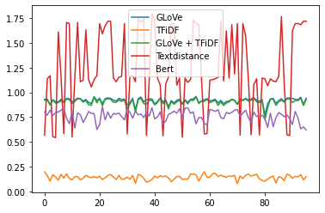

Full Document

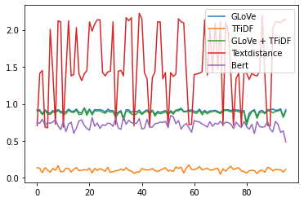

Responsibilities

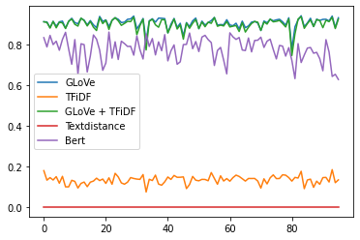

Requirements